**User’s documentation**

When you launch the application EasySave, a Graphical User Interface is opened.

You can choose the format in which the current day historic will be write, the file’s extension that you want to encrypt, and the business software that are incompatible with the execution of backups by clicking on the “settings” button (Picture 2). You can choose your preferred language by clicking on the “Langue / language” button (Picture 1).

Picture 1 - Languages

Picture 2 - Setting

You can create a backup by clicking on the adapted button. Give the asked information about the backup (name, source, destination, and type) with the keyboard (Picture 4). You can execute one or more backups by clicking on the adapted button. Write the numbers of the backup you would like to execute. Example: write 1-3 to execute backups from the number 1 to the number 3 and write 1;3 to execute backup 1 and backup 3. Click on “OK”, and the real time state of your backups will be displayed (Picture 3).

Picture 3 - Backup execution

Picture 4 - Backup creation

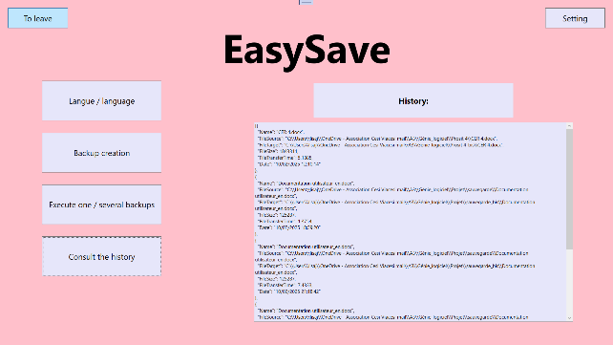You can consult the history file of the current day by clicking on the “Consult the history” button (Picture 6). To exit the application, click on “Exit” Picture 5).

Picture 5 - Exit

Picture 6 - History consultation